Registration form team tournament
Carlton International Youth Tournament 2021

With this form you can register for the Team tournament on the 30th of december.  Teams consist of at least 2 boys and 2 girls. The team will play in one of the age categories. Younger players can be assigned to higher age groups regardless of their matches in the individual CIYT tournament. If a team is incomplete or you just have a few players you want to sign up we will try to match them together with other players to form a full team. Registration forms should be sent to info@ciyt.nl |  |  | 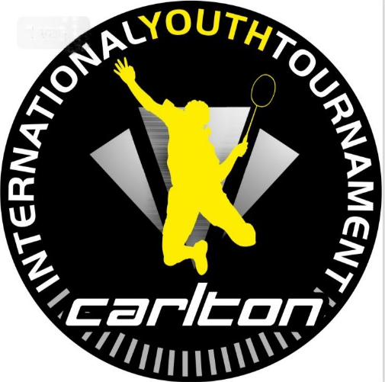
Name of coach: |  | Mail:
Name of team: |  | Category: |  | U11/U13/U15/U17
# | Name of player | M/F |  | Birth date
1
2
3
4
5
6
7
8
9
10

